**“SWIFTOPS”**

A

Major Project Report

Submitted in partial fulfillment of the requirement for the award of degree of



**Bachelor of Technology**

In

**Computer Science & Engineering**

Submitted to

**RAJIV GANDHI PROUDYOGIKI VISHWAVIDYALAYA,**

**BHOPAL (M.P.)**

**Guided by Submitted By**

Prof. Dayanand Yadav Prasanna Samadhiya 0832CS211141

Rachit Vijaywargiya 0832CS211149   
 Divyansh Dawar 0832CS223D04

**DEPARTMENT OF COMPUTER SCIENCE & ENGINEERING**

**CHAMELI DEVI GROUP OF INSTITUTIONS**

**INDORE (M.P.) 452020**

**2024-25**

**“** **SWIFTOPS”**

***A Major Project Report submitted to***

**Rajiv Gandhi Proudyogiki Vishwavidyalaya*, Bhopal***

**Bachelor of Technology**

in

Computer Science and Engineering

### ***by***

## **Prasanna Samadhiya (0832CS211141)**

## **Rachit Vijaywargiya (0832CS211149)**

**Divyansh Dawar (0832CS223D04)**

***Under the guidance of***

**Mr. Dayanand Yadav**

**Assistant Professor**



**Session: 2024-2025**

**Department of Computer Science & Engineering**

**Chameli Devi Group of Institutions, Indore**

**452020 (Madhya Pradesh)**

**DECLARATION**

We certify that the work contained in this report is original and has been done by us under the guidance of my supervisor(s).

1. The work has not been submitted to any other Institute for any degree or diploma.
2. We have followed the guidelines provided by the Institute in preparing the report.
3. We have conformed to the norms and guidelines given in the Ethical Code of Conduct of the Institute.
4. Whenever we have used materials (data, theoretical analysis, figures, and text) from other sources, we have given due credit to them by citing them in the text of the report and giving their details in the references.

#### Name and Signature of Project Team Members:

|  |  |  |  |
| --- | --- | --- | --- |
| **Sr. No.** | **Enrollment No.** | **Name of students** | **Signature of students** |
| 1. | 0832CS211141 | Prasanna Samadhiya |  |
| 2. | 0832CS211149 | Rachit Vijaywargiya |  |
| 3. | 0832CS223D04 | Divyansh Dawar |  |

**CHAMELI DEVI GROUP OF INSTITUTIONS, INDORE**



**CERTIFICATE**

Certified that the Major project report entitled, “ **SWIFTOPS** ” is a bonafide work done under my guidance by Divyansh Dawar, Prasanna Samadhiya, Rachit Vijaywargiya in partial fulfillment of the requirements for the award of the degree of Bachelor of Technology in Computer Science and Engineering.

Date: _________________________

(Mr. Dayanand Yadav)

Guide

__________________________ _________________________

(Dr. Shailendra K. Mishra) (Dr. Manoj Agrawal)

Head of the Department Project Coordinator

__________________________ _________________________

(Dr. Manish Shrivastva) ( )

Principal, CDGI (External)

## **CHAMELI DEVI GROUP OF INSTITUTIONS, INDORE**

**ACKNOWLEDGEMENT**

We have immense pleasure in expressing our sincerest and deepest sense of gratitude towards our guide **Mr. Dayanand Yadav** for the assistance, valuable guidance, and co-operation in carrying out this Project work. We express our sincere gratitude to **Dr. Manoj Agrawal** (Associate Professor, Dept. of CSE, Major Project Coordinator) for his valuable guidance and constant support. We are developing this project with the help of Faculty members of our institute and we are extremely grateful to all of them. We also take this opportunity to thank the Head of the Department Dr. Shailendra K. Mishra, and the Principal of Chameli Devi Group of Institutions Dr. Manish Shrivastava, for providing the required facilities for the project work. We are greatly thankful to our parents, friends and faculty members for their motivation, guidance and help whenever needed.

#### Name and signature of team Members:

* 1. Prasanna Samadhiya
  2. Rachit Vijaywargiya
  3. Divyansh Dawar

**List of Figures**

|  |  |  |
| --- | --- | --- |
| **Sr. No.** | **Figure** | **Page No.** |
| 1 | Data Flow Diagram | 14 |
| 2 | Use case Diagram | 15 |
| 3 | Class Diagram | 16 |
| 4 | Database Design | 17 |
| 5 | Entity Relationship Diagram | 18 |
| 6 | Activity Diagram | 19 |
| 7 | Sequence Diagram | 19 |
| 8 | System Architectural Design | 24 |
| 9 | Register and Home Page | 29 |
| 10 | Home Page | 29 |
| 11 | About Page | 30 |

**Abstract**

This project presents a DevOps automation tool designed to streamline and optimize the software development lifecycle through a combination of Continuous Integration/Continuous Deployment (CI/CD), server monitoring, and customizable workflows. By automating tasks such as code testing, deployment, and server health management, the tool reduces manual intervention, minimizes human error, and accelerates delivery cycles. The system’s real-time monitoring and notification features enable proactive management, providing alerts for performance issues and potential errors. Additionally, the tool’s modular and scalable design allows for easy integration with existing workflows and systems, offering teams flexibility to adapt processes according to project-specific needs.

With its robust architecture and intuitive configuration options, this tool empowers development and operations teams to achieve faster, more reliable releases and efficient resource management. The project aims to enhance productivity, quality, and collaboration within software teams, ultimately supporting continuous improvement in an agile, high-demand software environment.

**TABLE OF CONTENTS**

|  |  |
| --- | --- |
| **CONTENTS** | **Page No.** |
| Title Page |  |
| Declaration | I |
| Certificate by the Supervisor | II |
| Acknowledgment | III |
| List of Figures | IV |
| Abstract | V |
| **Chapter 1: Introduction** | 1 |
| 1.1 Rationale | 1 |
| 1.2 Project Overview | 1 |
| 1.3 Objective | 2 |
| 1.4 Scope | 2-3 |
| 1.5 Methodology | 3-4 |
| 1.6 Roles & Responsibilities | 4-6 |
| 1.7 Contribution of Project | 6 |
| 1.7.1 Market Potential | 7 |
| 1.7.2 Innovativeness | 7 |
| 1.7.3 Usefulness | 7 |
| 1.8 Report Organization | 8 |
| **Chapter 2: Software Requirement Specifications (SRS)** | 9 |
| 2.1 Introduction | 9 |
| 2.1.1 Product Overview | 9 |
| 2.2 Software Functional Requirements | 9-10 |
| 2.2.1 Distributed Database or Client Server Model | 10-11 |
| 2.3 Non-Functional Requirement | 11 |
| 2.3.1 Reliability | 11 |
| 2.3.2 Availability | 11 |
| 2.3.3 Security | 11 |
| 2.3.4 Maintainability | 11 |
| 2.2.5 Portability | 11 |
| 2.2.6 Performance | 12 |
| 2.4 External Interface Requirement | 12 |
| 2.4.1 User Interface | 12 |
| 2.4.2 Hardware Interface | 12 |
| 2.4.3 Software Interface | 12 |
| 2.4.4 Communication Interface | 12 |
| **Chapter 3: Software Design Description (SDD)** | 13 |
| 3.1 Introduction | 13 |
| 3.2 Design Overview | 13 |
| 3.2.1 Data Flow Diagram | 14 |
| 3.2.2 Use-case Diagram | 15 |
| 3.2.3 Class Diagram | 16 |
| 3.2.4 Sequence Diagram | 17 |
| 3.2.5 Activity Diagram | 18 |
| 3.3 Database Design | 19 |
| 3.3.1 Entity Relationship Diagram | 20 |
| 3.3.2 Normalization Details | 21 |
| 3.3.3 Table Structure | 21-23 |
| 3.3.4 Data Dictionary | 23-24 |
| 3.4 Data Flow Diagram | 25 |
| 3.5 System Architectural Design | 26 |
| 3.6 Detailed Description of Components (Modules) | 27 |
| 3.6.1 Module 1 | 27 |
| 3.6.2 Module 2 | 27 |
| 3.6.3 Module 3 | 27-28 |
| 3.6.4 Module 4 | 28 |
| 3.7 User Interface Design | 28-29 |
| 3.7.1 Description of the User Interface | 29 |
| 3.7.2 Screen Images | 30-31 |
| **Chapter 4: Software Test Documentation (STD)** | 32 |
| 4.1 Introduction | 32 |
| 4.1.1 System Overview | 32 |
| 4.1.2 Test Approach | 32 |
| 4.1.3 Testing Objectives | 33 |
| 4.2 Test Plan | 33 |
| 4.2.1 Features to be Tested | 33-34 |
| 4.2.2 Features not to be Tested | 34 |
| 4.3 Test Cases | 34 |
| 4.3.1 Unit Testing | 35 |
| 4.3.2 Functional Testing | 35 |
| 4.3.3 System Testing | 35 |
| 4.3.4 Integration Testing | 35 |
| 4.3.5 Validation Testing | 35 |
| **Chapter 5: Conclusion and Future Scope** | 36 |
| References | 37 |

**Chapter-1**

**Introduction**

## Our Project is designed to revolutionize the software development process by automating critical tasks like Continuous Integration and Continuous Deployment (CI/CD), server management, and real-time monitoring. By integrating with platforms like GitHub, it automates code testing, building, and deployment, enabling faster, error-free software releases. It also manages server resources automatically, addressing issues like traffic spikes and downtime without manual intervention. With customizable workflows and real-time performance tracking, the tool adapts to each team’s unique needs, helping them focus on development while ensuring smooth, efficient, and reliable software delivery.

## **Rationale**

The increasing demand for rapid software development and deployment has highlighted the need for robust DevOps practices to streamline workflows and reduce human error. However, manual processes in code integration, testing, server management, and monitoring can slow down delivery, introduce risks, and impede scalability. This project addresses these issues by automating crucial stages of the software lifecycle, such as CI/CD, server health monitoring, and resource scaling. By reducing manual intervention and enhancing reliability, the tool enables development teams to innovate faster and maintain high software quality standards.

**1.2 Project Overview**

Our project streamlines the entire software development lifecycle by automating key tasks such as Continuous Integration and Continuous Deployment (CI/CD), server management, and real-time monitoring. By integrating directly with GitHub, the tool automates the testing, building, and deployment of code, enabling teams to deliver features more quickly and with fewer errors. Additionally, the tool manages server resources, automatically addressing issues like downtime or traffic spikes, while offering customizable workflows tailored to the unique needs of each project. With built-in monitoring and alert systems, teams can track the performance and health of their applications in real time. Our solution empowers development teams to focus on innovation, reducing manual tasks and minimizing the risk of errors, ultimately ensuring faster, more reliable software delivery.

**1.3 Objective**

**1. Automation of CI/CD Pipelines:**

To streamline the software development lifecycle by automating Continuous Integration and Continuous Deployment (CI/CD) processes, ensuring faster, error-free code delivery.

**2. Enhanced Server Monitoring:**

To automate server monitoring and resource management, ensuring high availability, automatic scaling, and recovery from failures without manual intervention.

**3. Real-Time Monitoring and Alerts:**

To provide real-time performance tracking and monitoring of applications, offering alerts and dashboards that highlight critical metrics such as memory usage, traffic, and server health.

**4. Customizable Workflows**:

To offer flexible, customizable workflows that allow development teams to tailor the tool according to their specific project needs, such as incorporating security checks or backups.

**5. To Increase Development Speed and Efficiency:**

To accelerate release cycles by reducing manual processes and operational bottlenecks, allowing teams to deliver new features and updates faster.

**6.To Reduce Human Error:**

To minimize the risks of manual mistakes by automating repetitive tasks, from code testing to deployment and server scaling.

**1.4 Scope**

The Project will provide an integrated platform to automate and streamline the software development, deployment, and operations processes. The tool's primary scope includes:

**1. CI/CD Automation:** Automating Continuous Integration (CI) and Continuous Deployment (CD) by integrating with version control systems (e.g., GitHub). This includes automatically testing, building, and deploying code changes to various environments with minimal manual intervention.

**2. Automated Server Monitoring:** Automating server provisioning, monitoring, and scaling to handle traffic fluctuations and system failures. The tool will ensure high availability by managing server health, load balancing, and auto-scaling based on predefined performance thresholds.

**3. Real-Time Monitoring and Alerts:** Offering real-time tracking of application performance metrics such as CPU, memory usage, error rates, and server uptime. It will provide instant alerts to teams through configurable channels (e.g., email, Slack) in the event of system failures or performance degradation.

**4. Customizable Pipelines and Workflows:** Allowing teams to define, configure, and customize their CI/CD pipelines to include stages such as security checks, code quality checks, and other project-specific tasks. Users can tailor workflows based on their development needs and methodologies.

**1.5 Methodology**

The methodology will follow an iterative, Agile-based approach to ensure continuous improvement, feedback integration, and quick delivery of functional features.

**Requirement Analysis**

Gathering requirements from stakeholders, such as developers, system administrators, and project managers. Defining key performance indicators (KPIs) for system efficiency, scalability, and reliability.

**Architecture Design**

Creating a scalable, modular architecture that supports CI/CD, server management, and monitoring functions. Defining the technology stack for building the tool.

**CI/CD Pipeline Development**

Building an automated pipeline for continuous integration and deployment to streamline code testing and delivery. Integrating the tool with version control systems (e.g., GitHub) to automatically trigger builds and tests upon code commits. Configuring automated testing frameworks to run unit, integration, and security tests. Building deployment scripts that automate application deployment to multiple environments.

**Server Monitoring**

Implementing health checks and auto-scaling mechanisms to handle server failures or traffic spikes. Setting up load balancing to distribute traffic efficiently across multiple servers.

**Real-Time Monitoring and Alerts**

Implementing monitoring tools to track performance metrics (CPU usage, memory, disk I/O, network traffic) and generating logs. Configuring alerting mechanisms that notify teams via email, SMS, or Slack in case of performance degradation or system failures.

**Workflow Customization**

Allowing users to define custom workflows and tailor the pipeline to meet specific project needs. Building a user interface that allows teams to configure their own CI/CD pipelines.

**Datasets**

While this project does not specifically involve traditional datasets in the form of structured data, it relies heavily on various types of data that guide its functionality:

Version Control Data: GitHub, GitLab, or other version control platforms.

Test and Build Data: Testing frameworks Junit and build tool Gradle.

Server Performance Metrics: Monitoring tool like Prometheus.

Deployment Logs: Logging framework ELK stack.

Alert Data: Integrated alerting systems like PagerDuty.

**1.6 Roles & Responsibilities**

Member 1

Technologies Used: Jenkins, Prometheus, Docker

Role:

Responsible for setting up and managing Continuous Integration and Continuous Delivery (CI/CD) pipelines and server monitoring.

Implements Infrastructure as Code (IaC) and manages cloud infrastructure.

Responsibilities:

* CI/CD Pipeline Setup: Configured and maintained Jenkins to automate build, test, and deployment processes.
* Server Management: Implemented health checks and auto-scaling mechanisms to handle server failures or traffic spikes.
* Containerization: Worked with Docker to containerize applications for consistent deployment across environments.
* Version Control: Managed Git repositories to ensure smooth code integration and version control.

Member 2

Technologies Used: Next. Js( Front End), Git, RESTful APIs

Role:

Responsible for designing and implementing the user interface (UI), ensuring a user-friendly, intuitive, and responsive platform.

Responsibilities:

* Collaborated with team members to understand user requirements and implement UI features based on those insights.
* Ensured the user interface is intuitive, responsive, and aligned with user needs, focusing on ease of use and accessibility.
* Implemented reusable UI components and integrated them into the application to maintain a consistent look and feel across different pages of the tool.
* Handled API responses and rendered data dynamically on the frontend, ensuring smooth interactions with the automation workflows and real-time status updates.

Member 3

Technologies Used: Next.js(Backend), OAuth

Role:

Responsible for developing and managing the backend components, APIs, and databases that power the DevOps automation tool. Additionally, responsible for server setup, configuration, and maintaining backend infrastructure.

Responsibilities:

* Automated the deployment of backend services and ensured the system was continuously tested, built, and deployed consistently.
* Respond to incidents involving backend performance, API failures, or security breaches.
* Troubleshoot issues with the backend systems, databases, or server infrastructure, and quickly resolve them to minimize downtime.

**1.7 Contribution of Project**

* Using Jenkins, Docker, and Git, we built a fully automated DevOps pipeline for streamlined deployment, testing, and monitoring.
* Developed a responsive and user-friendly web interface for interacting with the DevOps tool, ensuring that users can easily monitor pipelines, deployments, and system statuses.
* Implemented authentication mechanisms and secured communication channels to protect sensitive data.
* Built the core backend services and APIs to handle data flow, authentication, and interaction between various parts of the DevOps tool.
* Set up the web servers and cloud infrastructure, ensuring a secure and optimized environment for the tool to run.

**1.7.1 Market Potential**

The market potential for a DevOps platform is substantial, given the growing reliance on agile methodologies and cloud-based applications across industries. Businesses aim to accelerate their development cycles, ensure reliable deployments, and reduce operational costs. As organizations adopt DevOps practices, demand for tools that offer CI/CD, server automation, monitoring, and custom workflows will continue to grow, especially among enterprises seeking scalability and enhanced infrastructure management. Additionally, the increasing trend toward AI-powered and predictive DevOps solutions suggests a strong future market expansion for innovative automation tools.

**1.7.2 Innovativeness**

The DevOps Platform is highly innovative as it integrates multiple automation components—CI/CD pipeline, server management, monitoring, and custom workflows—into a single, user-friendly platform. Unlike standard tools, it combines flexibility with modular customization, allowing teams to tailor automation steps to their specific needs, enhancing productivity and reducing errors. The tool's potential for AI-driven predictive monitoring and real-time adjustments in server resource allocation further demonstrates innovation by enabling proactive management and scalability. This adaptability makes it a forward-looking solution for evolving development practices.

**1.7.3 Usefulness**

The DevOps Platform is highly useful for modern development teams, as it streamlines and automates essential processes, reducing manual work, errors, and time-to-deployment. By integrating CI/CD, server management, monitoring, and custom workflows, the tool optimizes development cycles and infrastructure stability. It allows developers to focus on code rather than managing complex deployments or server issues. Real-time monitoring and predictive capabilities help ensure system reliability, while customizable workflows provide flexibility, making this tool a valuable asset for teams aiming for fast, reliable, and scalable software delivery.

**1.8 Report Organization**

The organization of this report ensures a logical flow, guiding the reader through the project's various stages, from introduction to conclusion. Each chapter is structured to provide clear and detailed information about specific aspects of the project, enabling a comprehensive understanding of the development and implementation of the DevOps Automation Platform. This organized approach also highlights the contributions of the student team, demonstrating their collective and individual efforts in bringing the project to fruition.

Chapter-2

**Software Requirement Specifications**

**2.1 Introduction**

The Software Requirement Specification (SRS) for the DevOps Project provides a structured document detailing the software’s purpose, functional requirements, non-functional requirements, and overall scope. This document serves as a blueprint for stakeholders, developers, and testers, offering a comprehensive understanding of what the software will accomplish. The SRS also defines the technical and performance expectations, ensuring alignment with industry standards and project objectives. By establishing clear requirements, the SRS enables efficient design, development, and validation processes, ensuring that the final product meets user and business needs.

**2.1.1 Product Overview**

The Platform is designed to streamline and automate key processes in software development, including CI/CD pipeline management, server monitoring, and workflow customization. It integrates multiple features such as automated code deployment, server management, performance monitoring, and customizable workflows into a unified platform. This tool enhances software quality, speeds up release cycles, and improves operational efficiency by eliminating manual tasks and providing real-time insights into system health. Targeting development teams and enterprises, the tool offers a reliable solution for scalable, continuous software delivery.

**2.2 Software Functional Requirements**

**1. Automated Code Integration and Deployment (CI/CD):**

Implementing automated testing, building, and deployment workflows to streamline code integration and deployment processes. We are tracking and managing deployment statuses, with automatic rollback on failures.

**2. Server Monitoring and Management:**

Continuously monitoring server health, performance metrics, and resource usage.

Automatically scaling server resources based on traffic and restarting servers upon failure.

**3. Custom Workflow Configuration:**

Allowing users to set up custom testing, security, and compliance checks within the deployment pipeline. Enabling users to adjust the CI/CD workflow to fit team-specific needs.

**4. Real-Time Alerts and Notifications:**

Sending real-time alerts for server issues, deployment failures, and security risks.

**5. Dashboard and Analytics:**

Providing a dashboard for viewing performance metrics, resource usage, and deployment history.

**2.2.1 Distributed Database or Client Server Model**

**1. Data Distribution and Replication:**

The system supports distributed data storage, enabling databases to be replicated across multiple servers. It ensures data consistency across servers using data replication protocols.

**2. Data Availability and Redundancy:**

The system is resilient, and ensures high availability and redundancy, allowing continuous access to data even if one server fails.

**3. Client-Server Communication:**

The client and server communicate efficiently, allowing secure data retrieval and updates. It uses secure protocols (e.g., HTTP/HTTPS, gRPC) for data exchange.

**4. Load Balancing:**

The system distributes requests across servers to balance load, ensuring optimal response times and resource utilization.

**5. Backup and Recovery:**

Regular backups are performed to secure data integrity. The system supports fast recovery from failures, minimizing downtime.

**8. Authentication and Authorization:**

The system includes secure authentication mechanisms and enforces user-level authorization for data access.

**2.3 Non-Functional Requirement**

**2.3.1 Reliability**

It Ensures high uptime and minimizes failure risks through automated monitoring and self-healing mechanisms.

**2.3.2 Availability**

The system supports load balancing across distributed servers, ensuring continuous operation and accessibility even during high-traffic periods or system updates

**2.3.3 Security**

Enforced strict access controls, data encryption, and conducted security scans on each deployment

**2.3.4 Maintainability**

Ensured modular code for easier updates, bug fixes, and the addition of new features

**2.2.5 Portability**

It supports multiple operating systems and is compatible with major CI/CD and DevOps platforms. It is easy to deploy across environments without requiring extensive reconfiguration, enabling teams to adapt it to their infrastructure effortlessly.

**2.2.6 Performance**

Maintained quick response times for real-time monitoring and data visualization, even with large-scale deployments.

**2.4 External Interface Requirement**

**2.4.1 User Interface**

The UI is intuitive and user-friendly, enabling developers and DevOps engineers to easily configure, monitor, and control workflows. The dashboard displays real-time metrics, alerts, and status updates for CI/CD pipelines, server health, and monitoring.

The interface must support customization options, including workflow adjustments, notifications, and role-based access.

**2.4.2 Hardware Interface**

The Platform runs on commonly available servers, supporting standard hardware configurations.

**2.4.3 Software Interface**

The platform provides seamless integration with version control systems like Git, as well as container platforms (e.g., Docker, Kubernetes). Provides Compatibility with monitoring tools (e.g., Prometheus, Grafana) for extended functionality. Supports integration with notification services (e.g., Slack, email) for alerting.

**2.4.4 Communication Interface**

Communication is secured using HTTPS protocol. Data between distributed servers and client systems is encrypted to ensure security. Real-time updates and data synchronization are supported across components to ensure accuracy and prompt action in monitoring and alerting.

Chapter-3

**Software Design Description**

**3.1 Introduction**

The Software Design Description (SDD) outlines the architectural and design decisions for the DevOps project, detailing how the system’s components will be structured and interact. The SDD defines the system architecture, data flow, module interactions, and interface specifications necessary to fulfill functional and non-functional requirements. This document serves as a bridge between requirements and development, providing a clear, structured view of each component’s purpose, behavior, and interaction. By ensuring design consistency and scalability, the SDD guides developers in implementing a robust and maintainable solution.

**3.2 Design Overview**

The design overview of the project highlights the system's architectural structure, detailing the integration and flow of processes required for efficient software deployment and management. It combines automated workflows for CI/CD (Continuous Integration/Continuous Deployment), server monitoring, and real-time notifications, emphasizing modularity and scalability. The design includes several main components: the CI/CD Pipeline, Custom Workflow Module, Server Monitoring Module, and Notification Service, each designed to streamline development operations. Each module is interconnected, facilitating code testing, deployment, monitoring, and performance alerts, thus optimizing the entire software lifecycle.

The database and configuration stores support efficient data flow and storage, ensuring seamless operations and customization. The design allows for easy extension and adaptation by leveraging a layered approach, supporting robust performance, user flexibility, and continuous project growth.

**3.2.1 Data Flow Diagram**

A Data Flow Diagram (DFD) visually represents the data flow within a system, showing how inputs are transformed into outputs through various processes. In a DFD for a DevOps Automation Tool, the main components include modules for CI/CD pipelines, server monitoring, custom workflows, and notification services. External entities such as users, source code repositories, monitoring systems, and deployment servers interact with these modules.

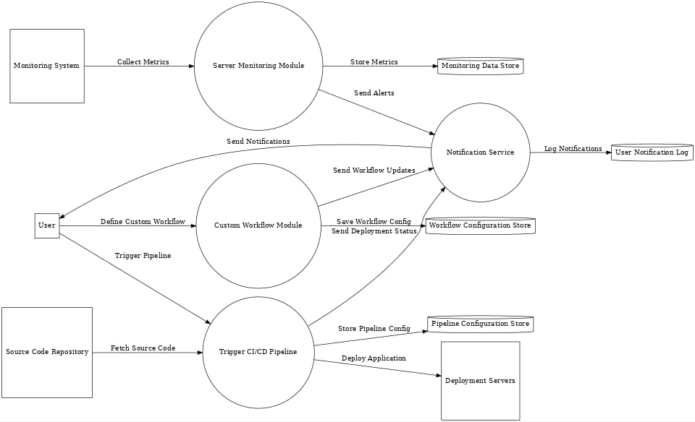

**Fig.1 Data Flow diagram**

**3.2.2 Use-case Diagram**

A use case diagram visually represents the interactions between a system and its users (actors), illustrating how users interact with the system to achieve specific goals. These diagrams are a key part of the Unified Modeling Language (UML) and help stakeholders understand the system's functionality and requirements. They show the various use cases (sets of actions) the system performs in response to user interactions.

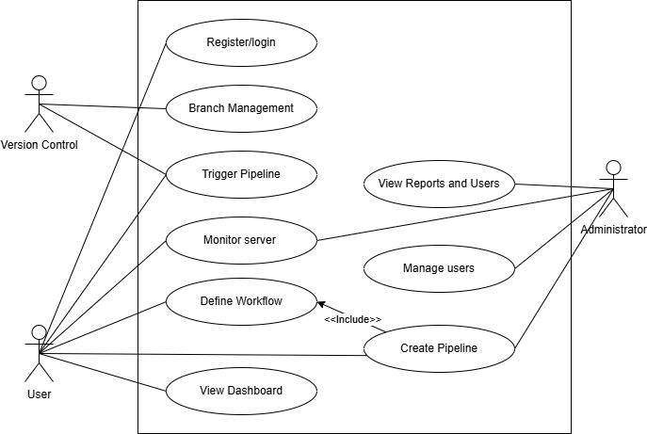

**Fig.2 Use Case Diagram**

**3.2.3 Class Diagram**

A class diagram is a type of UML diagram that visually represents the structure of a system by showcasing its classes, attributes, operations, and relationships. It's a static representation, meaning it depicts the elements of a system without showing their interactions or flow. Class diagrams are essential for object-oriented modeling, helping visualize and document the structure of a system to aid in code construction and design

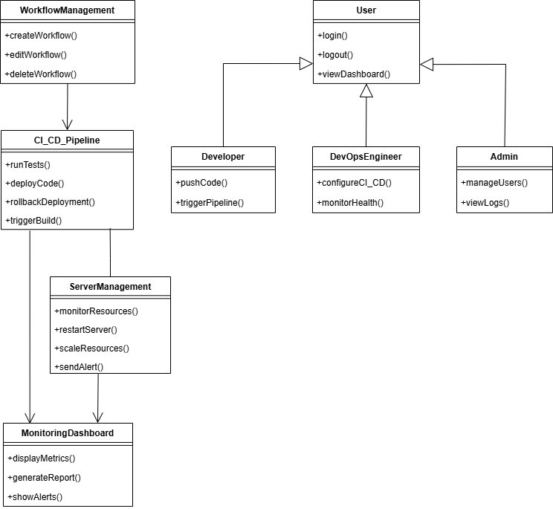

**Fig.3 Class Diagram**

**3.2.4 Sequence Diagram**

A sequence diagram is a type of Unified Modeling Language (UML) diagram that visually represents the interactions between objects in a system over time. It depicts the objects involved, their lifelines (representing their existence), and the messages exchanged between them in a specific order.

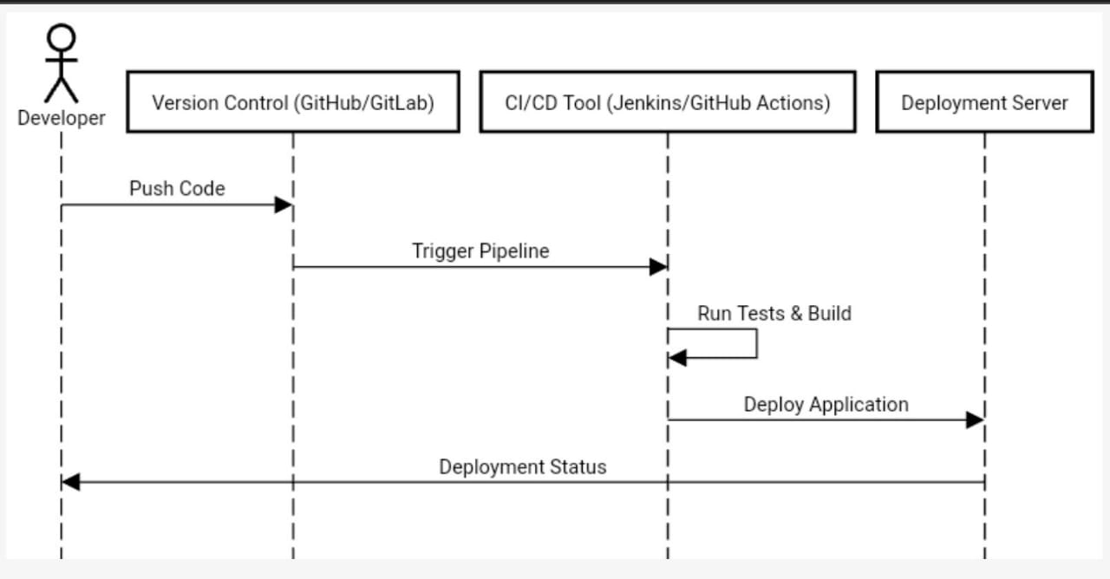

**Fig.6 Sequence Diagram**

**3.2.5 Activity Diagram**

Activity diagrams can be regarded as a form of a structured flowchart combined with a traditional data flow diagram. Typical flowchart techniques lack constructs for expressing concurrency. However, the join and split symbols in activity diagrams only resolve this for simple cases.

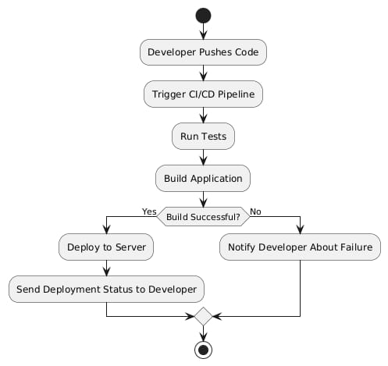

**Fig.7 Activity Diagram**

**3.3 Database Design**

Database design is the process of organizing data according to a database model, determining what data to store, how it interrelates, and defining data types and constraints for efficient and reliable data management.

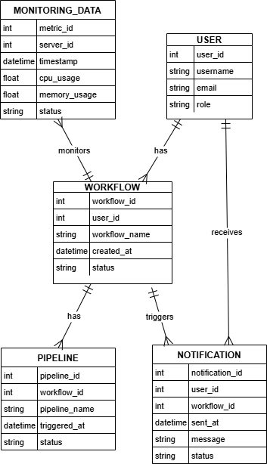

**Fig.4 Database Design**

**3.3.1 Entity Relationship Diagram**

An Entity Relationship (ER) Diagram is a type of flowchart that illustrates how “entities” such as people, objects or concepts relate to each other within a system. ER Diagrams are most often used to design or debug relational databases in the fields of software engineering, business information systems, education and research. Also known as ERDs or ER Models, they use a defined set of symbols such as rectangles, diamonds, ovals and connecting lines to depict the interconnectedness of entities, relationships and their attributes.

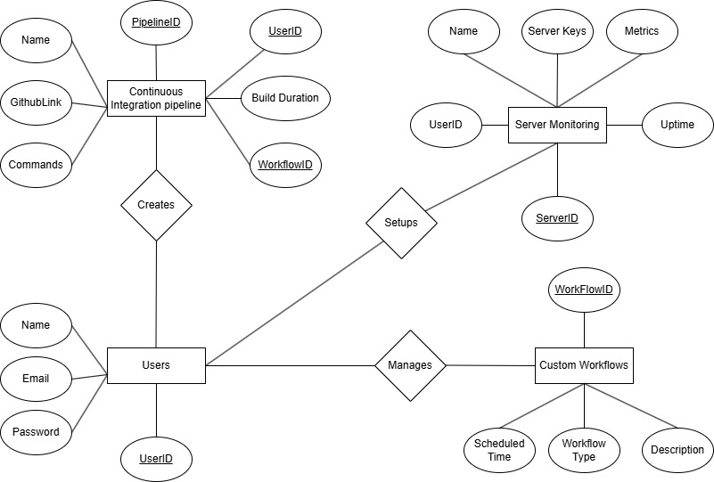

**Fig.5 Entity Relationship Diagram**

**3.3.2 Normalization Details**

For our project, database normalization typically involves organizing tables to reduce redundancy and dependency. Here’s a breakdown of normalization applied up to the third normal form (3NF):

**1NF (First Normal Form)**

Objective: Ensuring each column contains atomic values, and each table has a unique identifier.

Application: Splitting multi-valued attributes. For instance, the WORKFLOW table stores individual steps, ensuring each step is in a separate row if needed.

**2NF (Second Normal Form)**

Objective: Removing partial dependencies (non-key attributes depend only on the primary key).

Application: Tables like PIPELINE or SERVER store data related to a unique primary key (pipeline_id or server_id), eliminating partial dependencies.

**3NF (Third Normal Form)**

Objective: Eliminating transitive dependencies (non-key attributes dependent on other non-key attributes).

Application: Separating tables like USER and PROJECT prevents storing user details within each project, allowing direct relationships between tables only through primary keys.

**3.3.3 Table Structure**

|  |  |  |  |
| --- | --- | --- | --- |
| Table | Column | Data Type | Description |
| USER | User_id | INT | Primary key; unique ID for each user |
|  | username | VARCHAR(50) | Unique name for user login |
|  | password | VARCHAR(255) | Encrypted password |
|  | role | ENUM | Role of user |
|  | email | VARCHAR(100) | Unique email address for the user |
| PROJECT | Project_id | INT | Primary key: unique ID for each project |
|  | Project name | VARCHAR(100) | Name of the project |
|  | Description | TEXT | Brief project description |
|  | Created_at | DATE | Project creation date |
|  | Owner_id | INT | Foreign key (USER.user_id); project owner |
| PIPELINE | Pipeline_id | INT | Primary key; unique ID for each pipeline |
|  | Pipeline name | VARCHAR(100) | Name of the pipeline |
|  | Project_id | INT | Foreign key (PROJECT.project_id); project association |
|  | Status | ENUM | Current status of the pipeline (Pending, Running etc.) |
|  | Last_run | DATE | Date when the pipeline last ran |
| WORKFLOW | Workflow_id | INT | Primary key ; unique ID for each workflow |
|  | Workflow_name | VARCHAr(100) | Name of the workflow |
|  | Pipeline_id | INT | Foreign key (PIPELINE.pipeline_id); pipeline association |
|  | steps | JSON/TEXT | Serialized step data for the workflow |
| SERVER | Serve_id | INT | Primary key; unique id for each server |
|  | Server_name | VARCHAR(100) | Name of the server |
|  | Ip_address | VARCHAR(15) | IP address of the server |
|  | Status | ENUM | Server status (Active, Inactive) |
|  | Project_id | INT | Foreign key (PROJECT.project_id); associated project |
| ALERT | Alert_id | INT | Primary key; unique ID for each alert |
|  | Server_id | INT | Foreign key (SERVER.server_id); associated server |
|  | Alert_type | VARCHAR(50) | Types of alert (e.g., Error warning |
|  | Alert_message | TEXT | Message describing the alert |
|  | Alert_data | DATE | Date the alert was generated |

**3.3.4 Data Dictionary**

1. USER

user_id: INT, Primary Key, Auto Increment

username: VARCHAR(50), Unique

password: VARCHAR(255)

role: ENUM('Developer', 'DevOps Engineer', 'Admin', 'User')

email: VARCHAR(100), Unique

2. PROJECT

project_id: INT, Primary Key, Auto Increment

project_name: VARCHAR(100)

description: TEXT

created_at: DATE

owner_id: INT, Foreign Key (references USER.user_id)

3. PIPELINE

pipeline_id: INT, Primary Key, Auto Increment

pipeline_name: VARCHAR(100)

project_id: INT, Foreign Key (references PROJECT.project_id)

status: ENUM('Pending', 'Running', 'Success', 'Failed')

last_run: DATE

4. WORKFLOW

workflow_id: INT, Primary Key, Auto Increment

workflow_name: VARCHAR(100)

pipeline_id: INT, Foreign Key (references PIPELINE.pipeline_id)

steps: JSON or TEXT (stores serialized steps data)

5. SERVER

server_id: INT, Primary Key, Auto Increment

server_name: VARCHAR(100)

ip_address: VARCHAR(15)

status: ENUM('Active', 'Inactive')

project_id: INT, Foreign Key (references PROJECT.project_id)

**3.4 Data Flow Diagram**

A Data Flow Diagram (DFD) visually represents the data flow within a system, showing how inputs are transformed into outputs through various processes. In a DFD for a DevOps Automation Tool, the main components include modules for CI/CD pipelines, server monitoring, custom workflows, and notification services. External entities such as users, source code repositories, monitoring systems, and deployment servers interact with these modules. Data stores hold configuration, metrics, and logs, while labeled arrows illustrate data movement, such as triggering workflows, fetching source code, and sending notifications. This layered flow helps stakeholders understand system functionality and data dependencies.

**3.5 System Architectural Design**

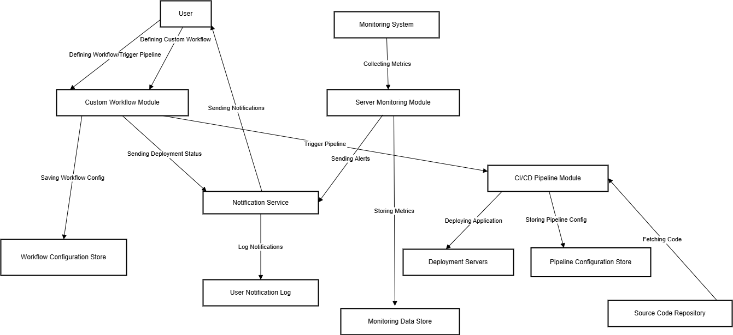

**Fig.8 System Architectural Design**

**3.6 Detailed Description of Components (Modules)**

**3.6.1 Module 1**

**CI/CD Module**

Purpose: Automates continuous integration and continuous deployment to streamline code testing and deployment processes.

Components: Code integration (automatically testing each change), build automation (creating executable versions of the code), and deployment (pushing code to production).

Functionality: Detects code changes in repositories (e.g., GitHub), runs tests, builds the application, and deploys to servers without manual steps. This module speeds up release cycles and reduces errors in deployments.

**3.6.2 Module 2**

**Server Management Module**

Purpose: Manages and monitors server health, scaling, and resource allocation to ensure high availability.

Components: Load balancer, scaling scripts, health check routines, and server monitoring.

Functionality: Monitors server resources (CPU, memory, storage) and auto-scales based on traffic or load conditions. It can restart servers, allocate additional resources, or notify the team if a server encounters issues. This ensures the uptime and reliability of deployed applications.

**3.6.3 Module 3**

**Workflow Management Module**

Purpose: Customizes and automates the workflow steps based on team-specific requirements.

Components: Customizable workflow editor, workflow scheduler, and pipeline management.

Functionality: Allows users to define unique workflows, such as running specific security tests, creating backups, or performing compliance checks before deployment. It enables flexible pipeline stages, letting teams adapt the automation tool to fit their development standards and practices.

**3.6.4 Module 4**

**Monitoring and Alerting Module**

Purpose: Provides real-time monitoring and alerting for applications and servers to maintain performance and reliability.

Components: Metrics collection, threshold alerts, notification system, and performance dashboards.

Functionality: Continuously monitors application and server performance metrics (latency, error rates, response times) and triggers alerts when metrics deviate from defined thresholds. It sends alerts to teams via email or other communication platforms and provides a centralized dashboard to review performance trends.

**3.7 User Interface Design**

**1. Dashboard:**

Overview of system status, active pipelines, server health, and recent alerts. Visual elements like charts and real-time metrics for server performance and pipeline activity.

**2. Pipeline Management:**

Interface to create, view, and manage CI/CD pipelines. Sections for setting up build steps, tests, and deployment targets, with status indicators for each step.

**3. Server Management:**

Displays list of servers, status (active/inactive), load metrics, and restart options.

Option to configure auto-scaling and set server-specific alerts.

**4. Workflow Customization:**

Drag-and-drop editor to design custom workflows with steps like testing, security scans, and backups.

Options to save, edit, and schedule workflows.

**5. Monitoring & Alerts:**

Visual dashboard with real-time monitoring of server and application health metrics.

Settings to configure alerts and notifications based on thresholds for CPU usage, memory, etc.

**6. User Management:**

User interface for managing team roles, permissions, and access control.

**3.7.1 Description of the User Interface**

**1. Dashboard:** Presents an overview of key metrics like pipeline status, server health, and recent alerts with visual aids like graphs and notifications. This gives users immediate insights into project status.

**2. Pipeline Management:** Allows users to view, create, and manage pipelines with an organized layout, showing the status of each build, test, and deployment step. Users can see logs, edit configurations, and monitor progress.

**3. Server Management:** Lists all servers along with their current status, resource usage, and health metrics. Users can configure auto-scaling settings and view historical performance data, with options to restart or troubleshoot issues directly.

**4. Workflow Customization:** Equipped with a drag-and-drop interface for creating workflows tailored to specific needs, enabling teams to set up detailed steps for CI/CD processes, testing, and backup tasks.

**5. Monitoring & Alerts:** Displays real-time performance metrics for applications and servers, with configurable alert settings. Users can set thresholds for alerts on resources like CPU and memory and view an alert history for detailed insights.

**3.7.2 Screen Images**

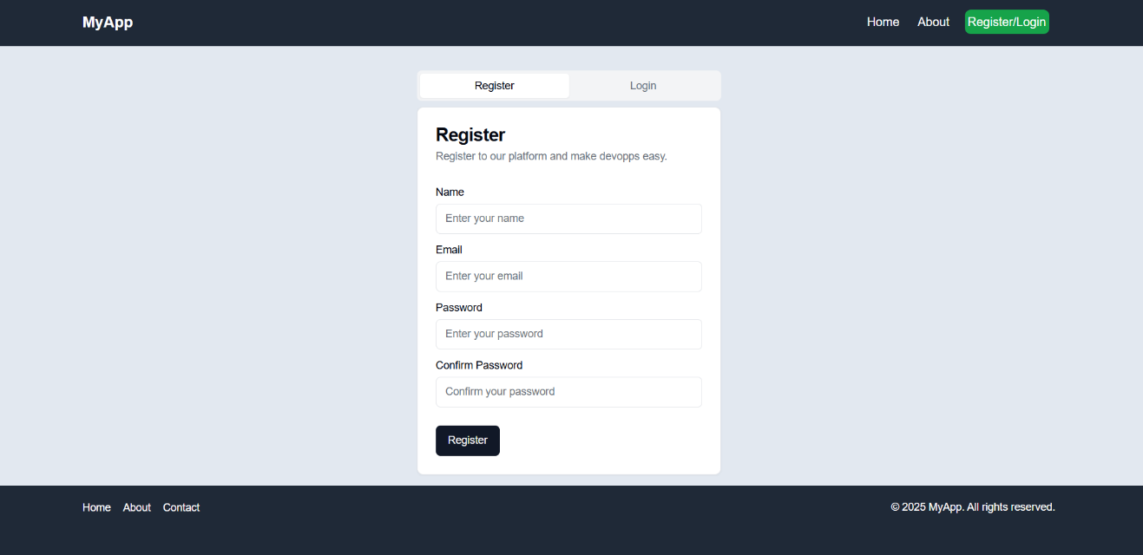

**Fig.9 Register and Login Page**

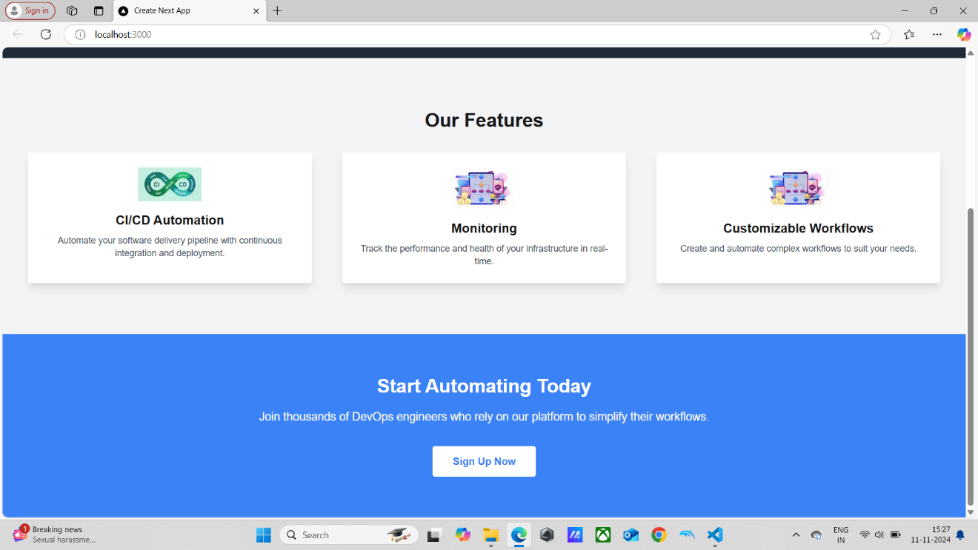

**Fig.10 Home Page**

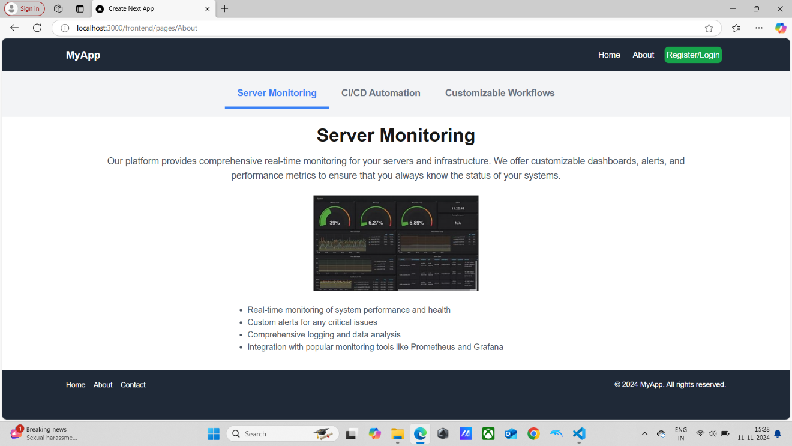

**Fig.11 About Page**

Chapter-4

**Software Test Documentation**

**4.1 Introduction**

The Software Test Documentation for the project outlines the testing strategies, methodologies, and cases applied to ensure the tool meets functional and non-functional requirements. This document confirms that each module (CI/CD, server management, monitoring, etc.) operates as expected, ensuring the tool’s reliability, efficiency, and security. It provides a comprehensive roadmap for testing activities, detailing procedures, test cases, and expected outcomes for validating the automation tool’s overall quality.

**4.1.1 System Overview**

The platform is designed to streamline and automate the CI/CD pipeline, server management, monitoring, and custom workflows for development teams. This tool integrates with repositories, supports automated deployment, monitors server health, and provides customizable workflows. The modular system has dedicated sections for CI/CD, server management, workflow management, and monitoring. Each module supports seamless functionality, making it easier for development teams to deploy code reliably, manage server resources efficiently, and monitor system performance in real time.

**4.1.2 Test Approach**

The project's testing approach includes manual and automated testing strategies to cover all functional and non-functional aspects of the system. Each module, such as CI/CD, server management, monitoring, and workflow customization, undergoes unit, integration, system, and acceptance testing to confirm seamless functionality and integration across modules. Performance testing evaluates responsiveness and scalability, while security testing verifies protection against vulnerabilities. The tests are executed in a staging environment closely mirroring production to replicate real-world conditions.

**4.1.3 Testing Objectives**

1. Verifying Core Functionality: Ensuring each module (CI/CD, server management, monitoring, workflows) works as intended.

2. Confirmation of System Integration: Testing interactions among modules to confirm data flow and functionality integration.

3. Assessing Performance and Scalability: Validating the tool’s ability to handle high workloads and scaling resources efficiently.

4. Ensuring Usability and Interface Reliability: Verifying the interface for user accessibility, responsiveness, and ease of use.

5. Validating Security and Data Integrity: Protecting the system against security vulnerabilities and confirming secure data handling.

6. Achieving Stability: Ensuring the system operation continuously without unexpected failures or downtime.

**4.2 Test Plan**

The test plan for the project outlines a structured approach to verify all core functionalities, integration points, performance standards, and security measures. The plan focuses on achieving high quality, ensuring that the tool meets all functional and non-functional requirements. Testing will be conducted in phases, including unit, integration, system, performance, and acceptance testing, and will utilize both manual and automated testing techniques to ensure comprehensive coverage.

**4.2.1 Features to be Tested**

**1. CI/CD Pipeline:** Code integration, build, testing, and deployment functionality.

**2. Server Management:** Monitoring, auto-scaling, load balancing, and server restart functionalities.

**3. Workflow Customization:** Ability to define, modify, and execute custom workflows.

**4. Monitoring and Alerting:** Real-time performance tracking, setting thresholds, and alert notifications.

**5. User Management:** Role-based access, permissions, and secure authentication.

**6. Data Management:** Data storage, logging, and backup capabilities.

**7. Settings and Integrations:** Integration with repositories, cloud services, and notifications.

**4.2.2 Features not to be Tested**

**1. Third-Party Integrations:** Functionality of third-party tools like GitHub or cloud providers, except where it affects core features.

**2. Database Internal Mechanisms:** Database engine-specific performance or security, as the focus is on correct data handling within the tool.

**3. Network Infrastructure:** The broader network infrastructure, outside the scope of in-tool networking configuration and usage.

**4. Non-Critical UI Aesthetics:** Minor visual aspects that do not impact functionality or usability.

**4.3 Test Cases**

* Verifying code integration upon a push to the repository.Validating deployment on a successful build.
* Monitoring server status for high CPU usage.Validating server restart functionality.
* Verifying custom workflow creation.Executing workflow with specific configurations.
* Setting alert thresholds for memory usage.Validating real-time dashboard updates.
* Verifying data logging during pipeline execution.Testing database backup functionality.

**4.3.1 Unit Testing**

Unit testing targets individual functions or components within the project, such as specific features in CI/CD, server management, and monitoring. By isolating each unit, these tests ensure that each part performs as expected and provides accurate outputs for given inputs.

**4.3.2 Functional Testing**

Functional testing assesses the tool's compliance with functional requirements. This includes verifying that CI/CD processes execute correctly, monitoring functions trigger alerts as configured, and server management features handle load balancing and restarts.

**4.3.3 System Testing**

System testing validates the end-to-end functionality of the entire platform in a staging environment, simulating real-world conditions. This ensures that all integrated modules (e.g., workflows, user management) work cohesively.

**4.3.4 Integrating Testing**

Integration testing focuses on the interaction between modules (e.g., how CI/CD integrates with monitoring or server management). This phase ensures data flows smoothly across modules and that combined functionalities meet system requirements.

**4.3.5 Validation testing**

Validation testing confirms that the platform meets the intended business and functional requirements. By verifying the full system against specifications, this phase ensures the tool is production-ready, delivering on efficiency, reliability, and usability expectations.

**Chapter-5**

**Conclusion and Future Scope**

**Conclusion**

The project streamlines software deployment, server management, and monitoring, enhancing efficiency and reliability for development teams. By automating critical processes and providing customizable workflows, the tool minimizes errors, accelerates deployment, and ensures system health. This project delivers a scalable, secure, and versatile solution for modern software development needs, supporting faster releases and reducing manual workload. It boosts team productivity and strengthens infrastructure stability, paving the way for rapid innovation and continuous improvement.

**Future Scope**

The project can evolve significantly with ongoing advancements in cloud computing, AI, and machine learning. Future iterations could include predictive analytics for proactive server management, AI-driven test automation to detect anomalies faster, and enhanced scalability for enterprise-level deployments. Additionally, integrating new development and containerization technologies will allow teams to adopt cutting-edge architectures. Expanding custom workflows with modular options and improving compliance automation for regulatory standards would ensure the tool remains adaptable and robust for diverse industry requirements.

**References**

1. S. Kumar and T. Li, "CI/CD Pipelines Evolution and Restructuring: A Qualitative and Quantitative Study," IEEE Transactions on Software Engineering, vol. 50, no. 1, pp. 120-130, 2024.
2. Sandeep Rangineni and Arvind Kumar Bhardwaj: " Analysis of DevOps Infrastructure Methodology and Functionality of Build Pipelines ", EAI.EU, 30 January 2024.
3. A survey paper on the design and implementation of CI/CD pipeline for automation using Jenkins by the International Research Journal of Modernization in Engineering Technology and Science, 2 February 2024.
4. M. A. Rahman, S. Shamsuzzaman, and A. K. Sarker, "Automating DevOps with GitLab CI/CD Pipelines: A Study on Efficiency and Deployment ", International Conference on Software Engineering, IEEE, 2023.
5. P. K. Roy, "Effect of Using Continuous Integration (CI) and Continuous Delivery (CD) in DevOps for Reducing Development Gaps," IEEE International Conference on DevOps Practices, IEEE, 2023.